BSI 10012 Compliance for Log360
Strengthen data protection and meet BSI 10012 compliance with Log360.
Region: EU, Germany | Type: Data Privacy | Category: Compliance | Pricing: Free

Overview
The BSI 10012 compliance extension in Log360 helps organizations meet BS 10012:2017+A1:2019, the BSI Personal Information Management System (PIMS) framework providing structured requirements for managing personal data throughout its lifecycle with GDPR alignment by providing centralized log management, data access auditing, and threat detection. The platform supports BSI 10012 requirements for PII processing conditions, access control for personal information systems, data subject rights, PII breach detection, audit and accountability evidence, and third-party processor oversight.
For Context and PIMS Scope Definition (Clause 4), Log360 monitors database DDL auditing, database DML auditing, file system changes, OneDrive file activities, and S3 bucket activity to provide visibility across personal data stores supporting PIMS scope definition. To address Leadership and Data Protection Policy (Clause 5), the platform monitors GPO auditing, Entra ID policy management, Entra ID role management, Entra ID directory management, and user auditing to demonstrate active PIMS policy governance. The extension also supports Risk Assessment and DPIA Planning (Clause 6) by providing capabilities that provides network attack reports, firewall security events, threat analytics, and vulnerability data to supply structured risk intelligence supporting DPIA and PIMS risk assessment processes.

Key Features
- PII Collection and Processing Conditions (Clause 8): Log360 monitors AD logon reports, Windows and Unix logon events, failed logon attempts, user auditing, and MFA authentication to enforce access controls protecting PII processing integrity.
- Data Subject Rights and Consent Management (Clause 8): Log360 tracks Entra ID user management, directory management, policy management, Exchange Online mailbox management.
- PII Security Breach Detection and Response (Clause 10): Log360 monitors cloud storage security incidents, Trend Micro events, FireEye reports, network attack and security reports, Windows threat detection.
- Audit, Accountability and Compliance Evidence (Clause 9): Log360 captures SQL Server and Oracle audit server records, Windows system events, event log reports, detailed system events, computer auditing.
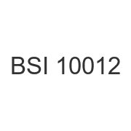
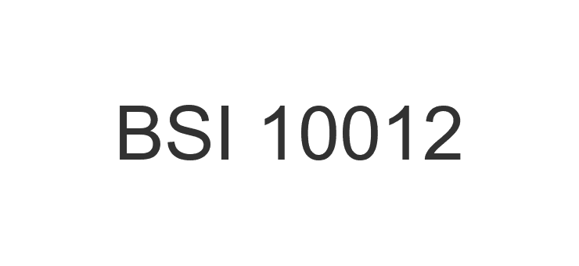
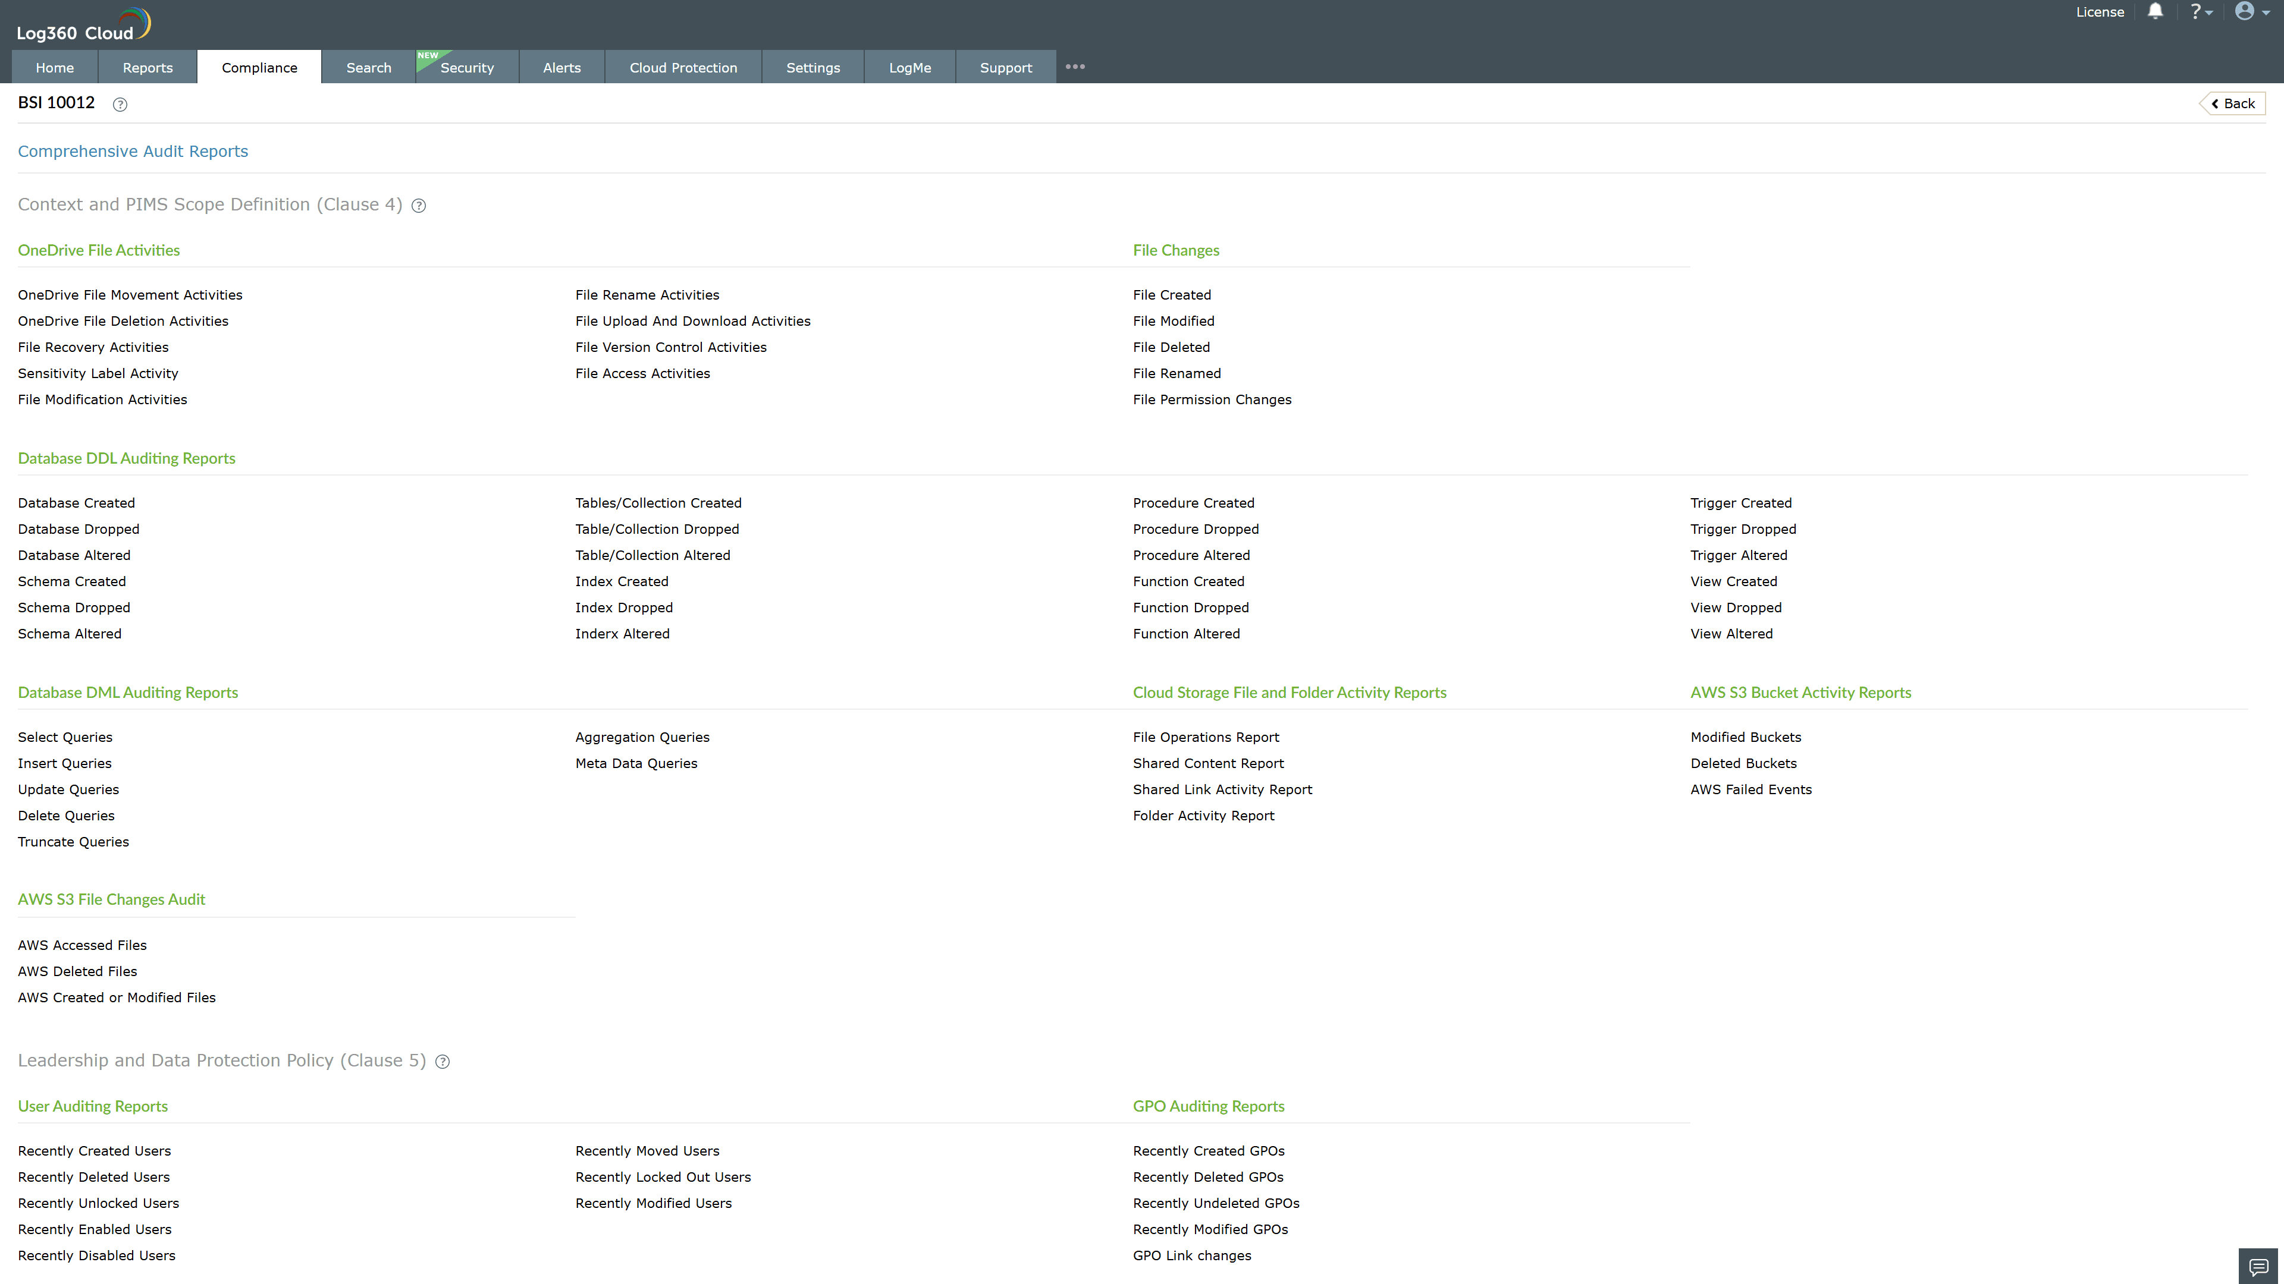
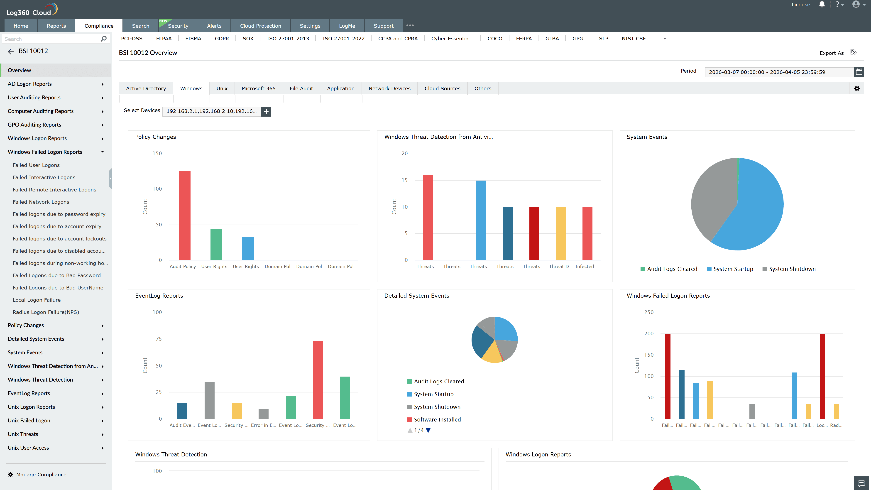
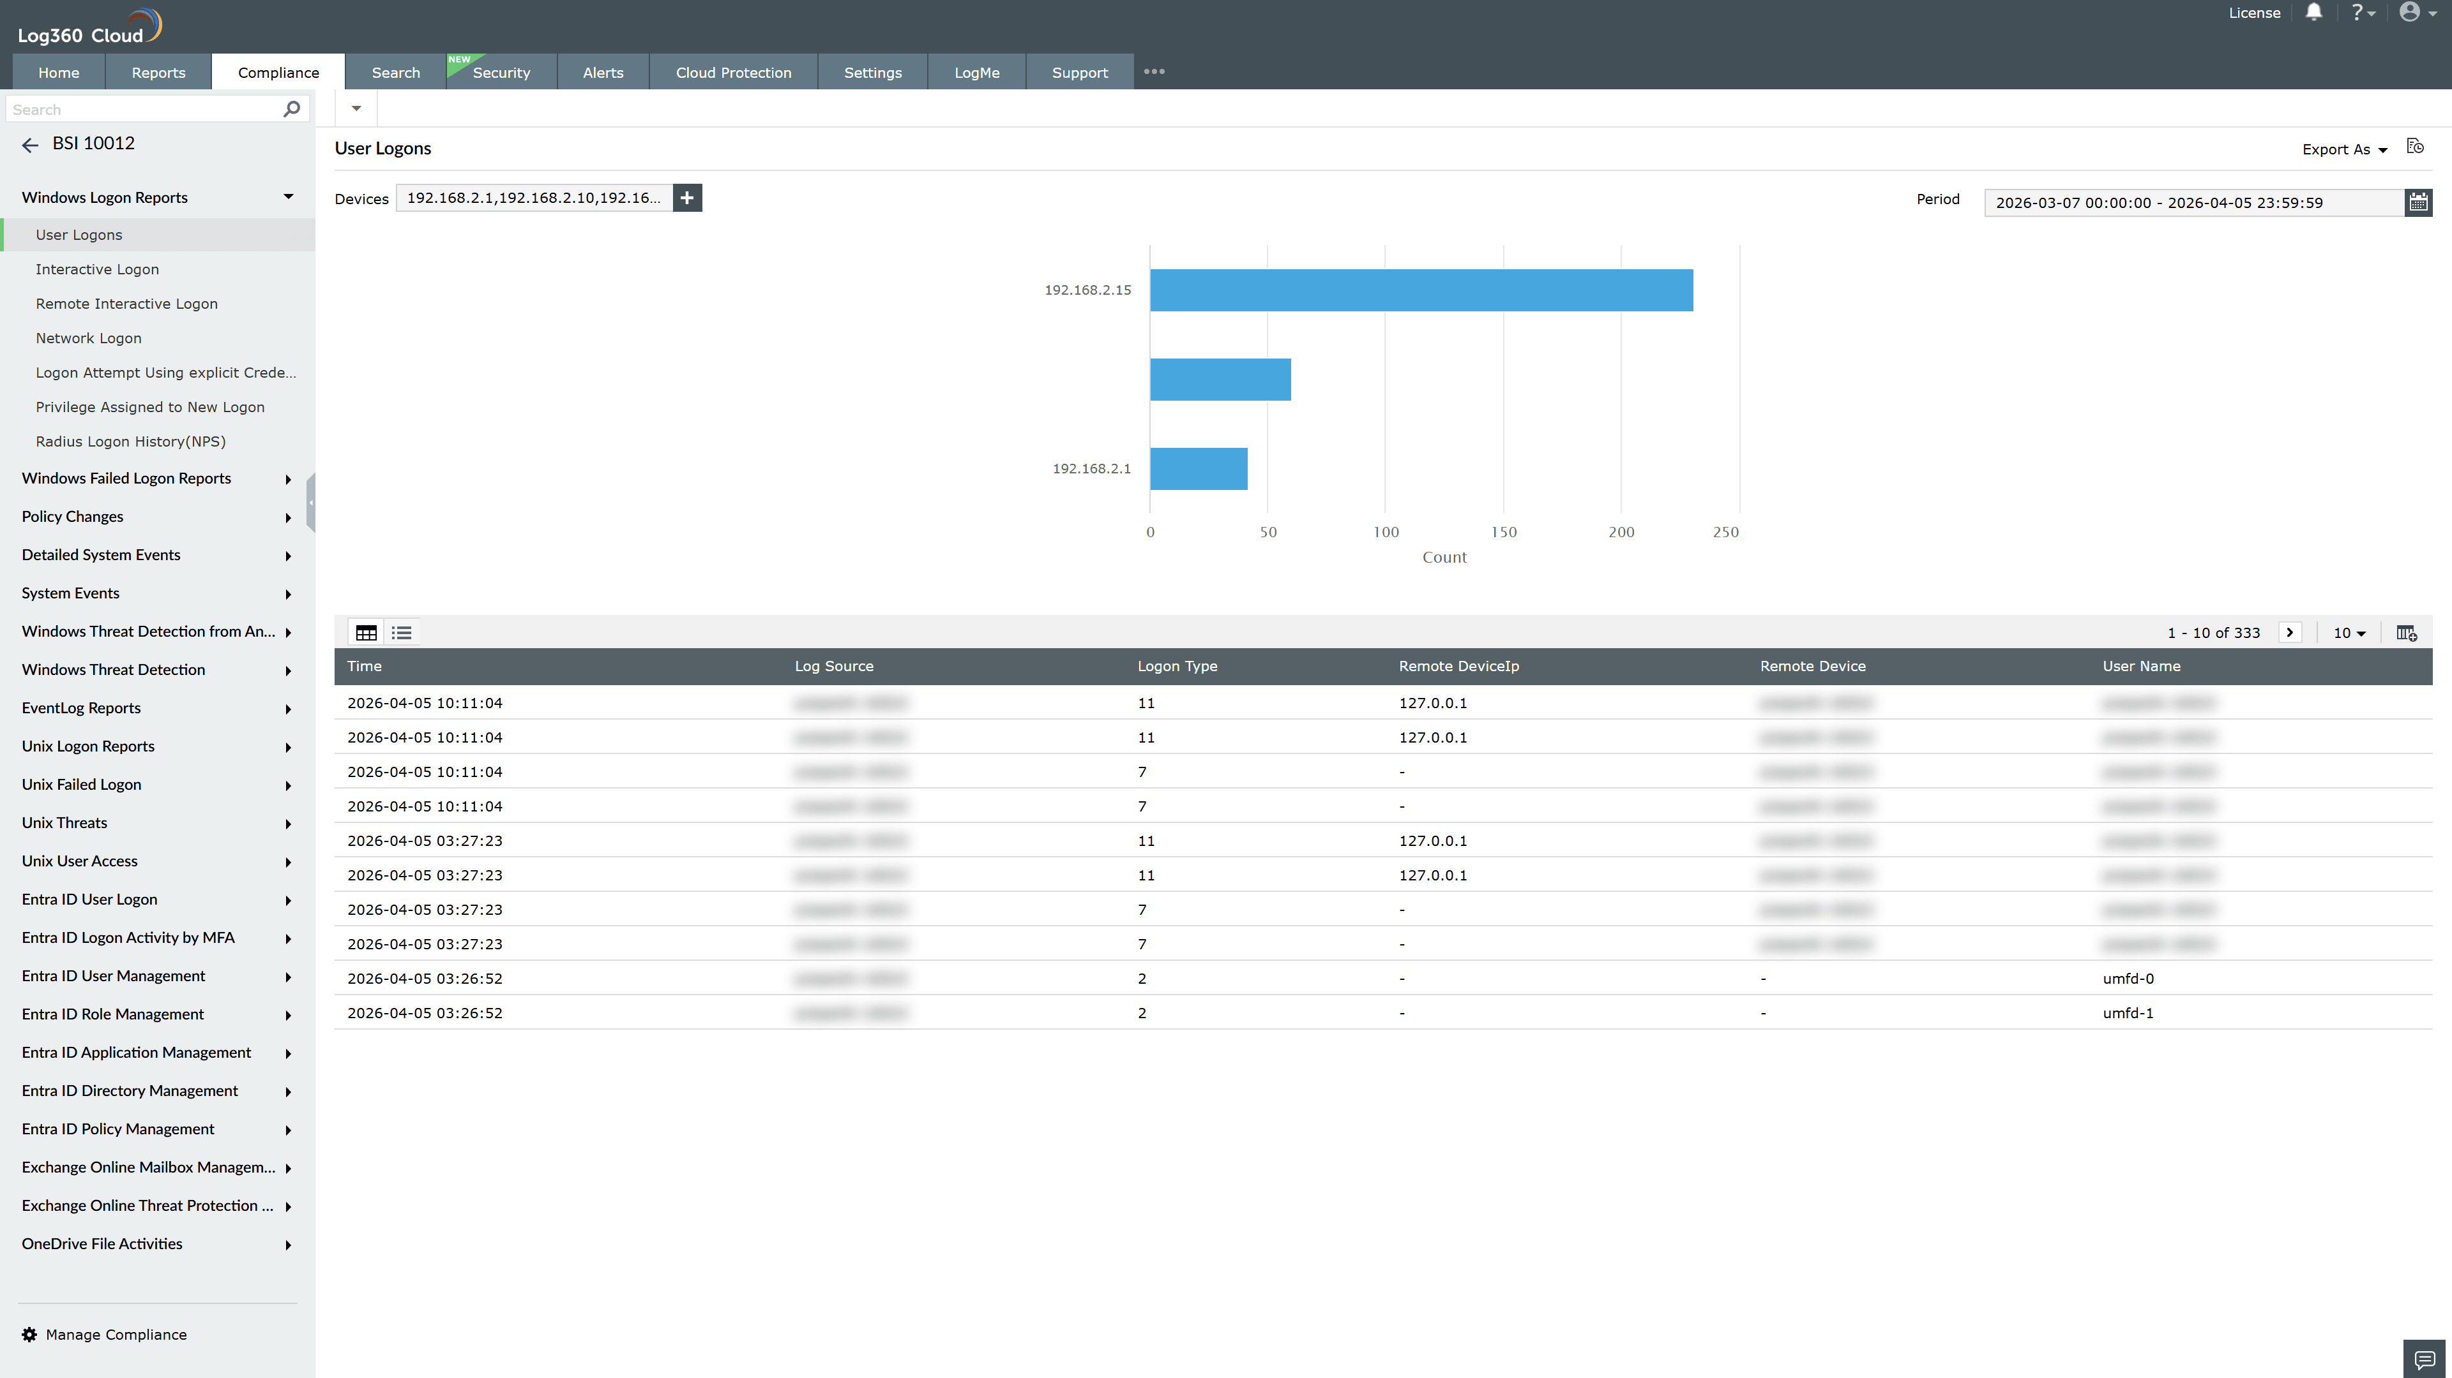
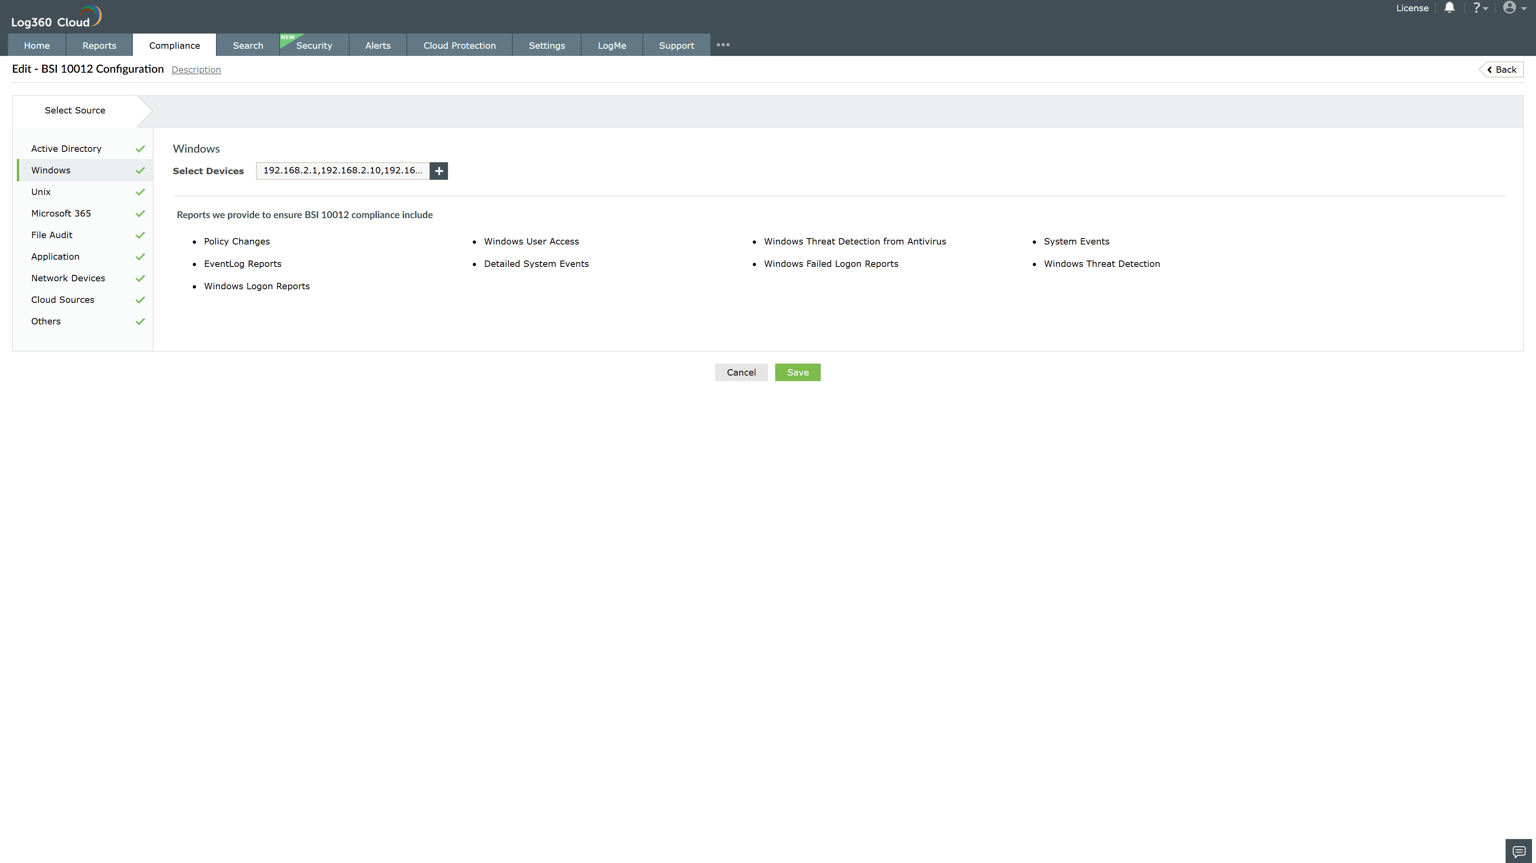
Valid Submission : Yes
Supported Editions : Free, Basic, Standard, Professional, MSSP
Help Document : https://www.manageengine.com/log-management/help/integrations/compliance-extensions.html
Help Video : Not provided
Tags : Log360, Compliance, Privacy monitoring, Data privacy, Regulatory compliance
Supported DCs : US, IN, JP, CA, AU, UK and EU
Privacy Policy:
Terms of Service:
Release Notes:
Predefined reports for the BSI 10012.

